CUSTOMER TABLE
- United states of america is replace with --USA
- Customer name is converted into capital letter also prefix Corrected
- Missing values in loyalty
- Customer id has some corrections-- c-1485 to CUST-4521
- 5 duplicate values are present
- Using COUNTA Function to count total number of customers
COUNTA(B2:B501)
PRODUCT TABLE
- Correction in p-3 to PROD 3

- Correction in missing values in stock and cost

- Missing values in stock is corrected by using statistical method mean
- Cost data type is converted to currency
- Find total cost using Sum function
- Subcategory removed
- Using SUMIF Function to find total cost of “clothing”
SUMIF(Table2[Category],"clothing",Table2[Cost])

Descriptive statistics
Stock
Mean | 268.95
Standard Error | 13.15155155
Median | 273
Mode | 273
Standard Deviation | 131.5155155
Sample Variance | 17296.33081
Kurtosis | -1.09075743
Skewness | -0.020492295
Range | 496
Minimum | 0
Maximum | 496
Sum | 26895
Count | 100

SALES TABLE
- Total Amount missing value is replaced by using this formula
Total Amount = Quantity*Unit Price/(1 -Discount)

- Find Performance

IF(totalamount>3500,"excelnt","good")

- Discount = 1 -(Total Amount/(Quantity*Unit Price))
- 9 duplicate value
- Highest price in unit price is highlighted by using
- data bars
- Top 10 highest discount is highlighted by using conditional formatting
- Total Amount column data type is changed
- Year is extracted from order_date by using TEXT Keyword
=TEXT([@[Order_Year]],"YYYY")
- This year used for creating dashboard
- Using vlookup find performance of store 7
=VLOOKUP(E13,E1:L91,8)

DASHBOARD
- Summary Cards:
  - Total Customers: 500
  - Number of Store: 20
  - Total Sales: 2174394
- Charts & Visualizations:
  - Top Sales (Sales Ranking): A bar chart illustrating top stores such as STORE12 (value 5), STORE17 (value 3), STORE3 (value 2), STORE4 (value 4), and STORE8 (value 1).
  - Stock (Sum of Total Stock): A doughnut chart breaking down stock by category: Beauty (4816), Clothing (4931), Electronics (5314), Home (4794), and Sports (7040).
  - Loyalty Level (Count of Customer): A column chart displaying customer counts across tiers: Bronze (125), Gold (122), Platinum (145), and Silver (104).
  - Top 10 Product (Sum of Total_Amount): A horizontal bar chart displaying product sales values, including PROD20 (16605.5037), PROD34 (17694.2172), PROD42 (19770.5232), PROD43 (15772.6566), PROD62 (15922.0094), PROD76 (19714.534), PROD80 (14216.9484), PROD91 (14338.7606), PROD94 (14655.8799), and PROD98 (13960.7317).
  - We can easily find out net profit
  - The donut chart represent payment type that help highest customer prefer which type

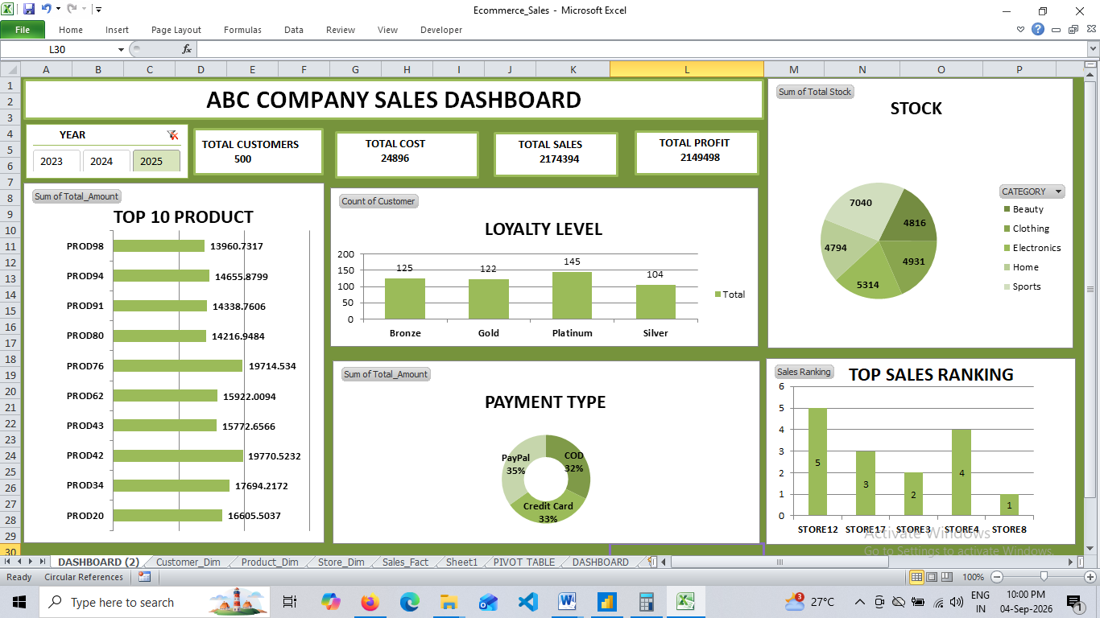
Screenshot
COUNTA
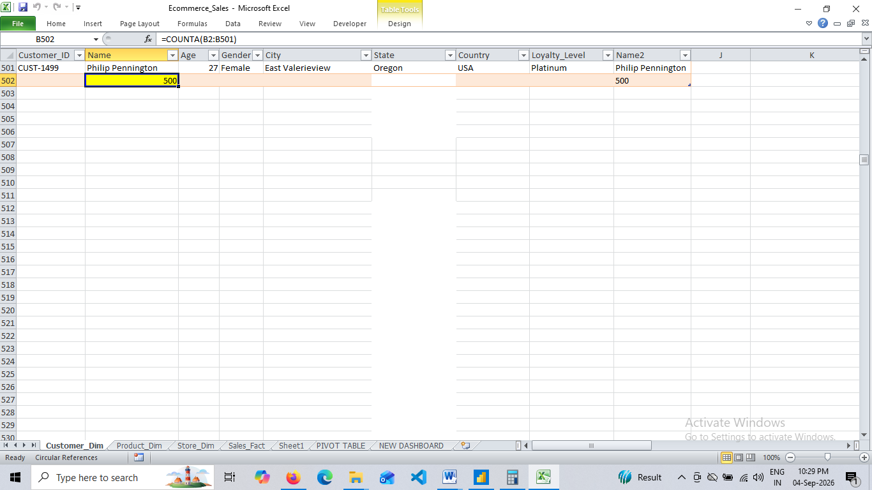

PROPER
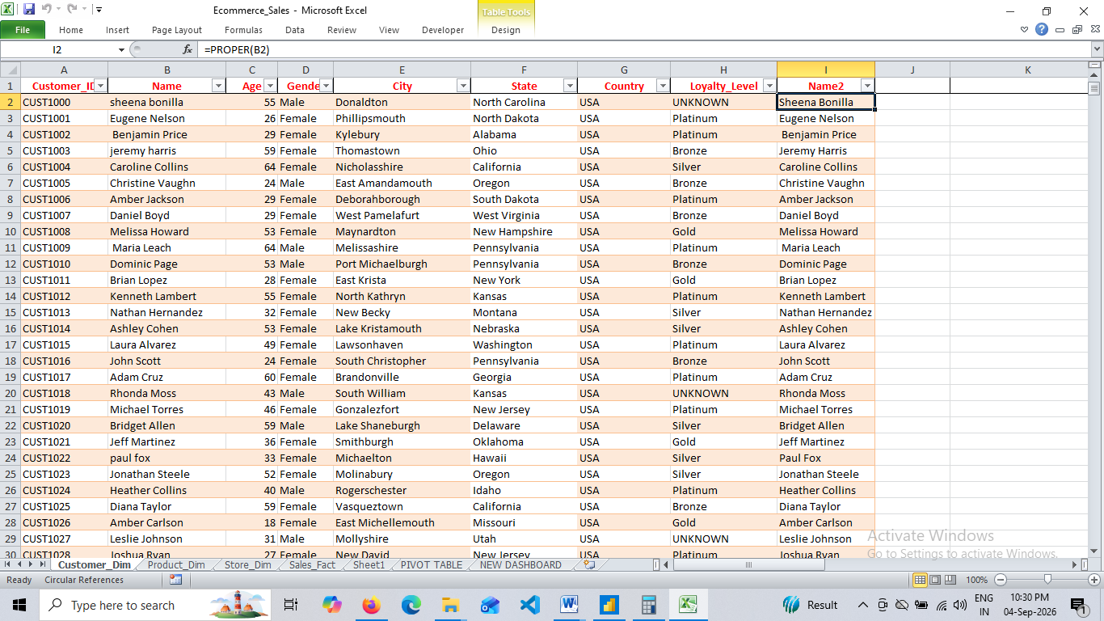
SUM
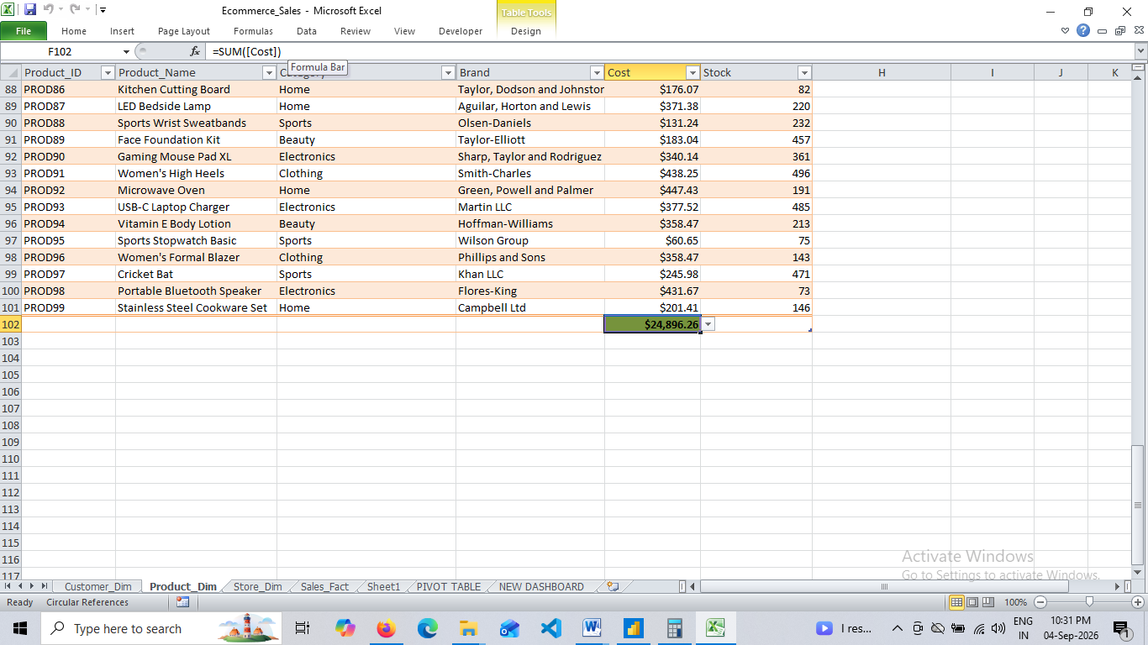
CONDITIONAL FORMATTING
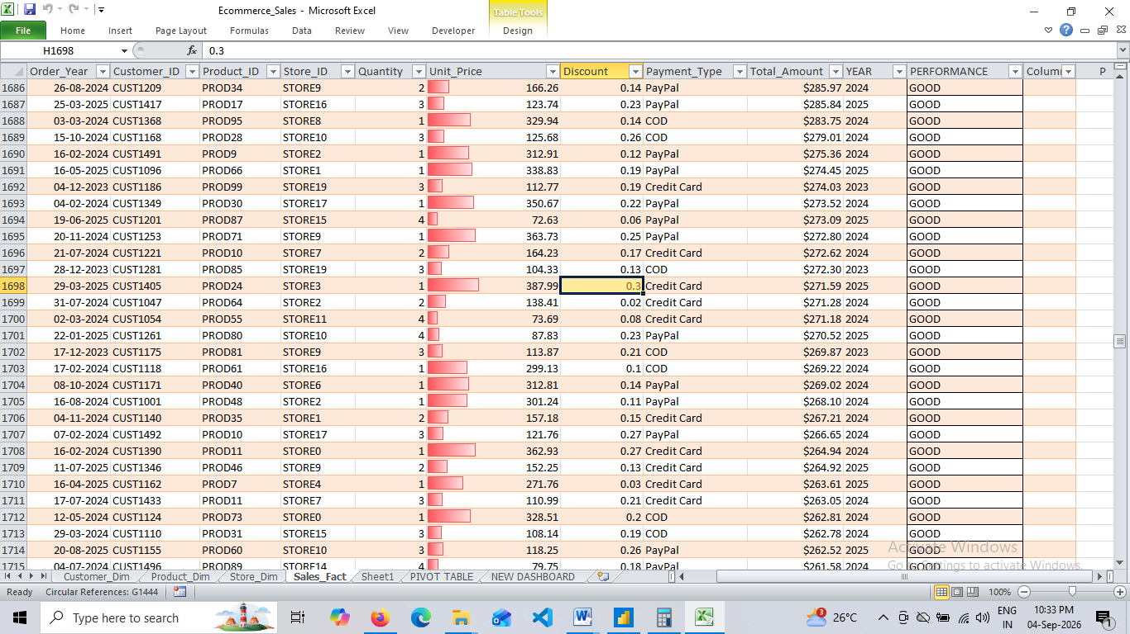
IF CONDITION
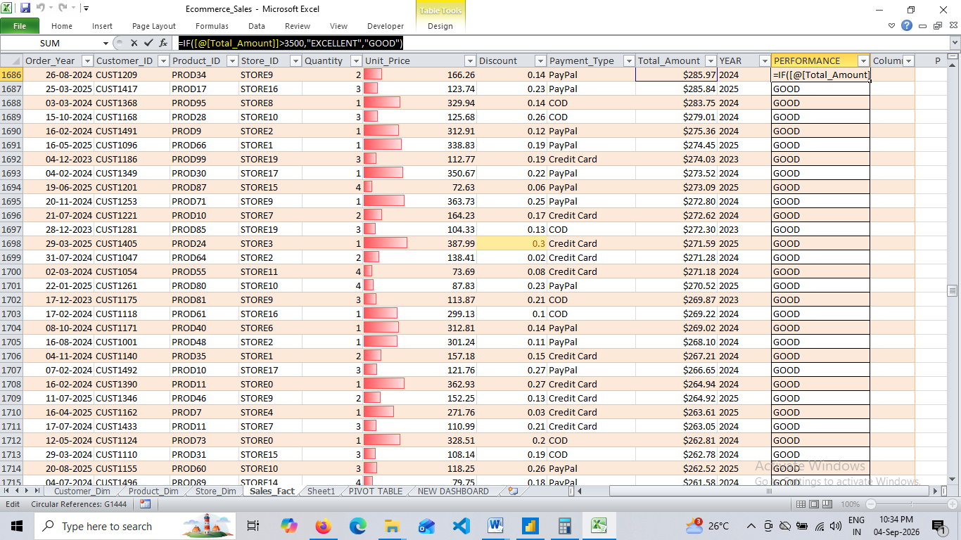
TEXT
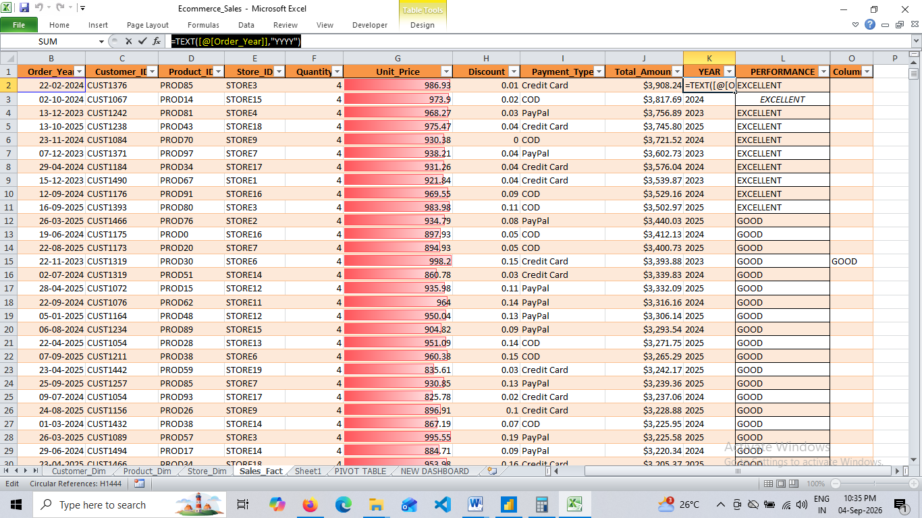
VLOOKUP
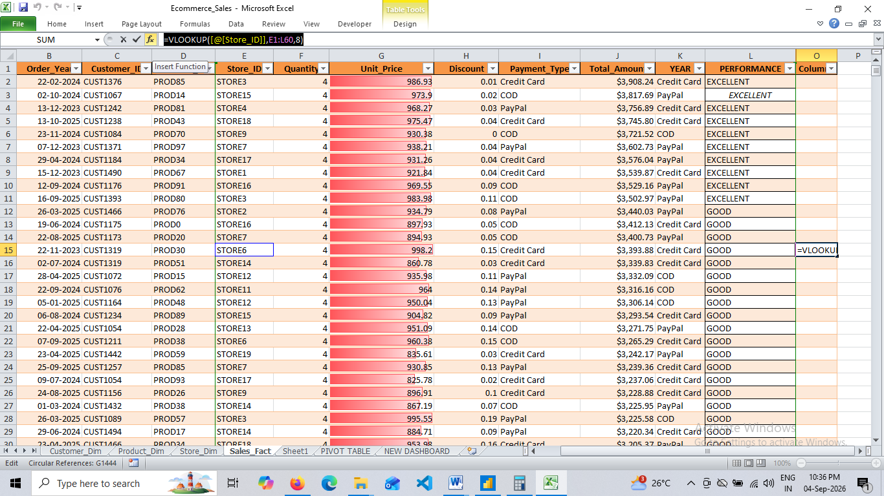
SUMIF
